Alex Brough

draw your reader in then bore them to death
TASK A
solar panel one

Contents
Business context 3
Functional requirements 3
Provide information about green energy products currently on the market. 3
Provide information to help users reduce their carbon footprint. 3
Provide consultations for users to reduce their carbon footprint. 4
Provide the option for installation of the products. 4
Calculations for carbon footprint. 4
Non-functional requirements 4
Accessibility 4
Usability 4
Performance 5
Sustainability 5
Empathy maps 5
Customer 5
Thinks 5
Does 5
Feels 5
Admin 5
Thinks 5
Does 6
Feels 6
Owner 6
Thinks 6
Does 6
Feels 6
Key performance indicators (KPIs) 6
User carbon footprint 6
Business financial performance 7
User understanding of the green energy technologies on the market 7
Decomposition diagram 7
Decomposition of the problem. 7
Navigation 8
Navigation bar 8
Footer 8
Pages 8
Home page 8
Consultation page 8
Appendix 8
Legislation 8
GDPR 8
WCAG 9
Personal Payment Information 9
Hardware and software 9
Hardware 9
Software 9
Coding languages 10
Emerging technologies 10
Floating solar panels 10
Ai energy management 10
Advanced energy storage system 11

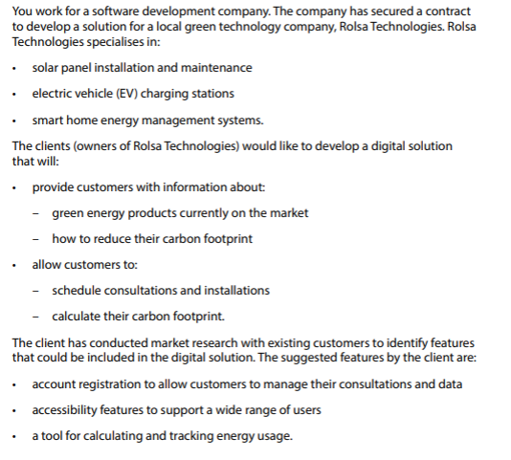
Business context

Functional requirements

Provide information about green energy products currently on the market.

- For this requirement there would need to be a page which allows the user to view information about the green energy products.

- The page would need to have detailed descriptions for each product allowing the user to gain insight into the products.

- The page would provide frequently asked questions which would allow users to get their questions answered without needing to contact the support team.

Provide information to help users reduce their carbon footprint.

- For this requirement there would need to be a page which allows the user to view information about the methods to help reduce carbon footprint.

- This page would have multiple methods of how to reduce carbon footprint each with their own detailed description allowing the users to gain insights into the methods of reducing carbon footprint.
- In order for the user to reduce their carbon footprint the carbon footprint calculator will be linked and a clear plan to reduce their carbon footprint will be displayed : Calculate carbon footprint identify areas for improvement via consultation install green energy products review changes to carbon footprint.

Provide consultations for users to reduce their carbon footprint.

- To provide consultations there will need to be a page that contains a form which would allow the user to book consultations.

- on the consultation booking form the user will enter their name, address and goals for what they want to achieve

- There will need to be a system which displays the availability of consultations based on what slots have already been taken this will ensure that sessions don’t get double booked.

- Consultations will need to have information available about what they contain to inform the user how to properly take advantage of them.

Provide the option for installation of the products.

Calculations for carbon footprint.

Non-functional requirements

Accessibility

Usability

- The system must be easy to use, easy to learn, and intuitive for all users. This will be achieved by following WCAG guidelines and standard web conventions.

- For this requirement, the system will provide a clear and consistent user interface across all pages to ensure users can easily understand how to interact with the website.

- Navigation menus and buttons will be clearly labelled and logically structured, allowing users to quickly access key features such as the carbon footprint calculator and informational pages.

- Clear instructions and guidance will be provided when users are required to input data, ensuring tasks can be completed with minimal effort and confusion. Security

Performance

Sustainability
User stories
As a …. | I want to... | So I can … | Acceptance Criteria
Customer who | Decrease my carbon footprint. | Feel better about my impact on the planet. | Go to consultation page  Type in information  Press book  Implement solutions suggested by the consultation  Go to products page  Press purchase on the items.
Customer who is concerned about their carbon footprint | Find out how much carbon I am releasing | Find ways to decrease it | Go to carbon footprint calculator  Type in information  Press calculate  Review results
Customer | I want to research the products available | Choose what products are best for me.
Customer | I want to get support on a query I have about a product. | Make an informed decision on the product.
Customer | I want to learn about this company. | So I can explore what the company offers.
Customer | I want to register an account | Own an account
Customer | I want to login to my account | Utilise the benefits of owning an account.
Customer | I want to view my bookings | View the information about my bookings.
Customer with booking | I want to cancel my consultation | So I can stop it from happening.
Customer | I want to view the polices | So I can be informed
Customer | I want to view the cookies | So I can be informed
Customer | I want to view legal information | So I can be informed

Empathy maps

Thinks | says | Feels | does
I want to understand how technology can help me reduce energy costs | How does this technology help me reduce energy costs? | Unsure | Go to the frequently asked questions and read an answer for their question.
How do I know the solutions are environmentally friendly? | Are your solutions environmentally friendly? | Worried | Go to the frequently asked questions and read an answer for their question.
I want to know how to book a consultation? | How do I book a consultation? | confused | Go to the frequently asked questions and read an answer for their question.
I am worried about installation do they provide help with installation or setup? | Do you provide help with installation? | concerned | Go to the frequently asked questions and read an answer for their question.
How can I track the performance of the system over time?

Customer
Says
I want to understand how your technology can help me reduce energy costs.
How do I know your solutions are environmentally friendly?
Can I monitor my energy usage through your platform?
Is there customer support if I need help with installation or setup?
How can I track the performance of the system over time?
Thinks
I hope the system is easy to integrate with my existing setup.
I’m concerned about the environmental impact of this technology.
I need the platform to be intuitive and user friendly.
I hope the pricing is clear, with no hidden fees or unexpected costs.
I want to be able to manage my energy usage efficiently through your app or website.
Feels
Excited about reducing energy costs and using greener technology.
Anxious if the technology isn’t as efficient or easy to use as promised.
Reassured if the website has clear information, customer reviews, and FAQs.
Satisfied when they can easily track their usage and see the savings.
Frustrated if it takes too long to set up or understand how to use the system.
Does
Researches the benefits of the technology on the website and third-party review sites.
Contacts customer support for more information or technical assistance.
Checks pricing options and payment plans available for the solutions.
Creates an account to track purchases, usage, and performance.
Signs up for updates or newsletters to stay informed about new products or features.
.

Key performance indicators (KPIs)

User carbon footprint
- The average user carbon footprint would be measured by storing the carbon footprint value every time a user calculates their carbon footprint this then this information will be used to calculate an average.
- To calculate the carbon footprint decrease after using the service carbon footprint could be calculated before and after the use of the website then these two values can be stored then the difference could be calculated.

Business financial performance
- Business financial performance can be monitored by keeping track of all revenue streams related to the website then calculating a total profit by taking away the costs of the company with the revenue generated.

User understanding of the green energy technologies on the market
- user understanding can be measured by measuring how many users access the frequently asked questions sections this will give an insights such as if there is enough information currently on the page users won’t be looking for more. This can also be measured though the user surveys for direct feedback from the customer.

Decomposition diagram

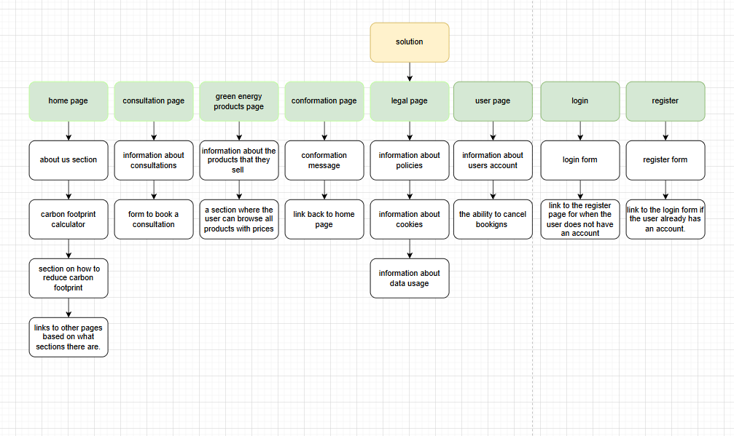

Decomposition of the problem.

Blue writing will be used for the justification.

DESCRIPTIONS OF THE PROPOSED SOLUTION

Navigation

Navigation bar
On every page there will be a navigation bar, this navigation bar will contain links which would allow the user to navigate the website effectively. On the navigation bar will be the links to the pages, home page, consultation, products and the user page. This will be consistent across all the pages which will allow for easy traversal of the page.

Footer
On every page there will be a footer which will contain links to all the pages on the website, this footer will be used to signify the end of the webpage along with provide efficient navigation to every page of the website.

Pages

Home page

On the home page there will be a header section with a call to action button which would direct users quickly to parts of the website they would like to go.
Next there will be an about us section which would give a general introduction to the company along with their goals and missions.
Next this would be the section would be the carbon calculator which is a section which would allow the users to enter all their information to allow for a calculation of their carbon usage.
Next would be a section on information on how to reduce carbon footprint this would include information about some of the products that the company sells and how they would decrease the user’s carbon footprint. This would be a small section which a link below it to a full page with all the products on it.
- there will be a header section on the page

Consultation page
On this page there will be information about the consultations what they contain there will be prices for the consultation types allowing users to make an informed decision.
Below this will be a form for booking the consultation in this form there will be the fields of, name, address, consultation type, and then they can book if the user clicks book without being logged in it will ask them to login or register which would then apply the booking after they completed these steps.
On this form there will be local and server side validation to ensure no errors occur.
Finally they will be redirected to the conformation page when the form is submitted successfully.

Green energy products page
On this page there will be information on the various products that the company provides there will be a grid of products each with their own descriptions and an option to add them to the basket
This basket can then be accessed and edited to remove or add products there will be also be functionality to check out with a link to a conformation page when purchase is successful.

Conformation Page
On this page there will be a message appropriate for whatever conformation message that the user needs to see. There will then be a link to the home page so the user can continue their browsing.

Legal page
The legal page will contain all of the information about the policies. What happens to the user’s data and the cookies that the website uses?

User page
Information about the users account will be displayed on this page, such as name, email address.
There will be functionality for the user to edit values such as their name and email and functionality to change their password. Furthermore the user will have the ability to log out of their account.
There will also be a section where the user can view their bookings and have the ability to cancel them here.

Login form
There will be a form which would allow the user to log in. on this form it would take email and password. There will also be a required checkbox for the user to accept the terms which would have a built in link to allow the users to see the policy page so they know what they are accepting. There will be a link to the login page if the user already has an account. after logging in there will be a conformation page saying they have registered successfully.

Register form
There will be a form which would allow the user to register in. on this form it would take name, email, password and repeat password. There will also be a required checkbox for the user to accept the terms which would have a built in link to allow the users to see the policy page so they know what they are accepting. There will be a link to the login page if the user already has an account. After registering there will be a conformation page saying they have registered successfully.

Admin page
The admin page would allow authorised admin users to view all booking and edit them from all accounts it would also contain ways to change prices on the website and text content to keep information up to date.

Risks
Not enough time to complete solution.
Make sure the project timing is well planned out to ensure that there is enough time for all elements to be completed giving time for setbacks and unforeseen events.
Not enough resources to complete solution.
Make sure resources are planned out and allocated efficiently to ensure that the project can be completed, furthermore make sure project is feasible with the current resources.
Not enough expertise to complete solution.
Make sure the staff have received additional training that they might need to complete the project.
The user may forget their username when logging in
Allow the users to reset their username with their email so they can always log in.
The user may enter an incorrect email address during registration
Provide error messages when the user provides an invalid email address. And to make sure it’s their email address and valid by sending conformation emails so the user can validate their account.
The user may mistype their password confirmation field
Don’t let the form submit when the passwords do not match and provide error messages when there is an issue.
The user may use a weak password that compromises account security
Implement validation to ensure that the user’s password is secure enough. Implement two factor authentication to reinforce.
The user may reuse a password from another website
Provide guidance on what to include in a password and discourage users form doing this.
The user may not receive the verification email due to spam filtering
The user may enter an expired or invalid verification link
The user may accidentally create multiple accounts
The user may abandon the registration process halfway through
The user may lose access to their registered email account
The user may enter incorrect personal information
The user may not understand password requirements
The user may experience session timeout while filling a form
The user may accidentally log out while performing an action

Appendix

Legislation

GDPR
GDPR is a legislation which governs how data is handled and collected, and this is applicable to the Rosla Technologies solutions due to the user information collected. Following this legislation requires the company to make sure they obtain clear consent for the data they are collecting, collect only required and necessary data to minimize data input, store collected data in a secure place, and provide clear explanations so the user understands how their data will be used and their rights under GDPR.

WCAG
WCAG is the web standards template aimed at making websites accessible to all users, including those with disabilities. These guidelines ensure that websites are usable by people with disabilities. For Rosla Technologies, compliance with WCAG ensures that their web solutions are accessible to a wider audience. To comply with this legislation the website would need to provide features such as accessibility mode which would have screen reading and accessible text.

Personal Payment Information
When processing personal payment information, Rosla Technologies must ensure that this data is handled securely following relevant regulations such as PCI .This involves encrypting payment data, using secure payment gateways, and limiting access to sensitive financial data to authorized personnel only. Additionally, users must be informed about how their payment information is used, stored, and protected during transactions.

Hardware and software

Hardware

Web hosting server
A web hosting server will be used to host the website on along with the database with all the clients’ personal information. This will allow it to be easily accessed and utilized for best functionality.

Personal computer
A computer will be needed to produce the code on.

Mobile device
This device will be used to test the responsiveness on other screen sizes along with the compatibility with touchscreens.

Tablet
This device will be used to test the responsiveness on other screen sizes along with the compatibility with touchscreens.

Software

Code editor
The code editor I will use is visual studio code this will allow me to take advantage of an organised file structure and comprehensive error detection to produce a high quality product.

Draw Io
Draw Io is a design program for flowcharts and algorithms this is used to produce understandable flowcharts to provide explanations for the algorithms included.

Canva
Canva will be used for the visual interface designs, it is an easy to use design program which allows for quick iteration of designs resulting in the best user experience.

Coding languages

HTML
Html will be used for the general page structure allowing elements to be placed and linked effectively on the webpage.

CSS
Css will be used for the visual styling of the webpage making it interesting and user friendly and accessible styles.

PHP
Php will be used for the server side language, using php I will be able to add advanced validation which would ensure the security of the system.

JS (JavaScript)
JavaScript will be used to make the webpages respond to the users’ inputs such as providing error messages or a personalised user dashboard with up to date info overall improving the user experience.

SQL
SQL will be used to query the database which would allow me to effectively retrieve and write data to the database to meet the functional requirements.

Emerging technologies

Floating solar panels

Floating solar panels which are placed on the water, these panels have many benefits over conventional solar panels such as: reduced evaporation of the body of water they are placed on this would reduce the water loss of reservoirs ensuring a stable supply of water for the community, increased efficiency due to the added cooling from the water.
Floating solar panels are a relevant emerging technologies for rosella technologies, this is due to the green energy applications which would be utilized by being listed as a product from the company this would provide relevant products for a modern company. This technology can also be used to power the datacentres which would align with the company’s net zero goal.

Ai energy management

AI energy management could be used to manage energy systems ensuring maximum efficiency with green energy systems making sure there are minimal losses of energy this means this emerging technology would be useful for Rosla Technologies as it would aid in achieving their net zero goal.

Advanced energy storage system

Energy storage systems could aid in the websites performance due to having back up power in the case of an outage. This also means that renewable but unreliable energy sources could be utilized such as wind and solar. This would create a better user experience due to the reliability of the hosting service which has the energy storage system to rely on if sources stop. Furthermore this could also be listed under the Rosla technologies

